Starting Oracle

# Getting an Account

ACS (Academic Computing) will be providing me with Oracle accounts to distribute to each of you.

# Logging in – there is more than one method

You can find instructions on

//zenith.senecac.on.ca

OR

http://zenit.senecac.on.ca:5560/isqlplus/

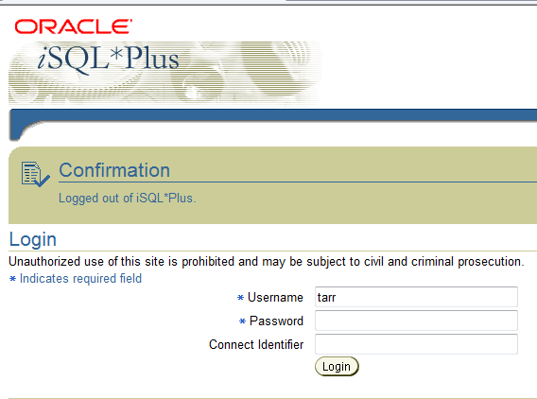

# Loading the script

Copy the script demobld10g.sql and load it into the entry screen. (CTL-A to highlight it, CTL-C to copy – set cursor in box and CTL-V and execute). This will build a series of tables used in the course.

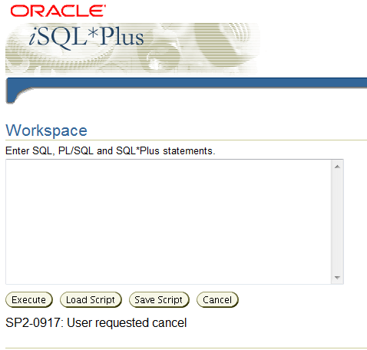

# Test it

Try out a few simple SQL commands to see if it works.